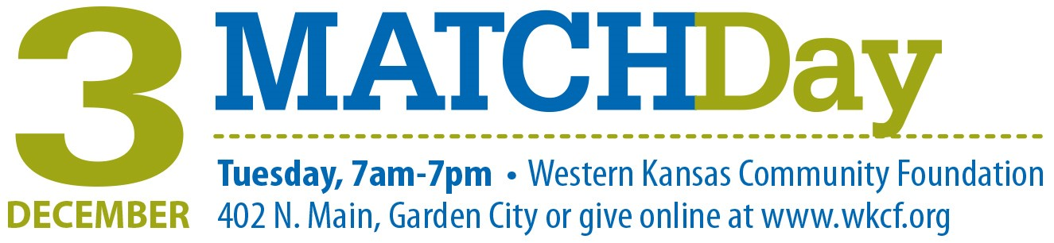
Your logo
We have the unique opportunity to multiply
funds given on MatchDay, December 3.
September [22st or later], 2019
Dear [Donor Name],
MatchDay on Tuesday, December 3, is an incredible opportunity for [name of your organization]. On that day, Western Kansas Community Foundation will match donations made to our organization and we could potentially receive 50% of the match pool.
How to donate:
- Come to the event and make a donation.
Date: Tuesday, December 3
Time: 7 a.m. – 7 p.m.
Place: Western Kansas Community Foundation (WKCF), 402 N. Main St.
or donate online at www.wkcf.org anytime from midnight to midnight
- The 2019 match pool is $75,000, and it will be divided among participating organizations in proportion to the total amount raised. We can earn up to 50% of the pool if contributions to our organization that day equal 50% or more of the total amount raised by all participating organizations.
- As extra incentive to donate in person, hourly prize grants will be given throughout the day, drawn from the previous hour’s donors contributing in person at the WKCF office. We can also earn prize grants if we raise the most money.
- Donations $20-$2000* per person, per organization are eligible for a match. Cash, checks and credit cards will be accepted.
*Only donations between $20 and $2000 will be matched, however all donations will be accepted.
- Donations are tax deductible and can be divided among multiple organizations. Checks must be made payable to Western Kansas Community Foundation. Receipt letters will be issued to each person making a donation.
[Name of your organization] is asking for you to dig deep, beyond what you give to our annual campaign.
We still face monthly expenses, so we still need your contribution to our annual campaign. However, building our endowment is critical to our future. MatchDay is a unique opportunity to benefit both of those needs, and to grow our endowment exponentially, so that we can enrich our people and programs for even greater impact, for years to come.
Sincerely,
[Name]
[Title]
P.S. This is a rare chance to multiply the difference we make, and it’s truly a missed opportunity if we aren’t able to take full advantage. Your gift is vital for helping us maximize the match.

