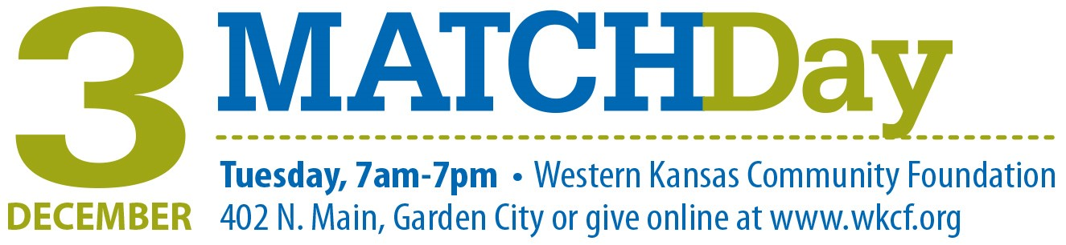

NONPROFIT NEWSLETTER STORY

Help Us Secure a $37,500 Match on MatchDay, December 3

MatchDay on Tuesday, December 3 holds incredible opportunity for [name of your organization]. On that day, Western Kansas Community Foundation will match donations made to our organization, and with your help, we could potentially receive a $37,500 match.

Here’s how Match Day works:

- Come to the event and make a donation.
Date: Tuesday, December 3
Time: 7 a.m. – 7 p.m. on-site
Place: Western Kansas Community Foundation, 402 N. Main
or donate online at www.wkcf.org anytime from 12 a.m.-11:59 p.m.
- The 2019 match pool is $75,000, and it will be divided among participating organizations in proportion to the total amount raised. We can earn up to 50 percent of the pool if contributions to our organization that day equal 50 percent or more of the total amount raised.
- As extra incentive to donate in person, hourly prize grants will be given throughout the day, drawn from the previous hour’s donors contributing in person. We can also earn prize grants if we raise the most money or have the most individual donors.
- Donations $20-$2000* per person, per organization are eligible for a match. Cash, checks and credit cards will be accepted.
*Only donations between $20 and $2000 will be matched, however all donations will be accepted.
- Donations are tax deductible and can be divided among multiple organizations. Checks must be made payable to Western Kansas Community Foundation. Receipt letters will be issued to each person making a donation.
Building our endowment is critical for our future, but we still face monthly expenses, so we still need contributions to our annual campaign. MatchDay is a unique opportunity to benefit both of those needs, and to grow our endowment exponentially, so that we can enrich our people and programs for even greater impact, for years to come. Contributions to [your organization name here] during MatchDay 2018 helped us [example of how MatchDay funds were used]. Your gift is vital for helping us maximize the match and allow us to continue providing the programs that are valuable to our corner of the state.

